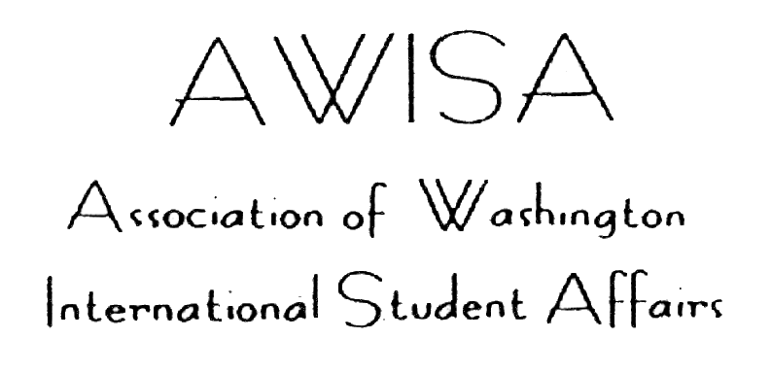

2005-2006 Membership/Invoice Form

Please enclose $15 for one person, $35 for two or more people. Different programs on the same campus should pay separately. Make checks payable to AWISA and mail to:

Leana de la Torre
University of Washington
1410 NE Campus Parkway
Box 355832
Seattle, WA 98195-5832

(If needed for your institution, AWISA’s Tax ID # is: 91-1612543)

Please attach business cards for all members in your program, or write the information below:

Name(s) & Title(s):

Program/Dept. & Institution
Address:

Phone: Fax:
Email(s):
Do you need a receipt for payment of dues? YES NO

Name of person to send receipt to:

Address (if different from above):

Chair | Secretary/Chair-Elect | Treasurer
Machelle Allman | Leana de la Torre | Brad Huggins
Highline Comm. College | University of Washington | Art Institute of Seattle
2400 S. 240th St. MS 6-14 | 459 Schmitz Box 355832 | 2323 Elliott Avenue
Des Moines, WA 98198 | Seattle, WA 98195-5832 | Seattle, WA 98121-1622
Tel.: (206) 870-3725 | Tel.: (206) 543-3672 | Tel.: (206) 239-2293
Fax: (206) 870-3738 | Fax: (206) 685-3511 | Fax: (206) 441-3475
mallman@highline.edu | torre@u.washington.edu | bhuggins@aii.edu

